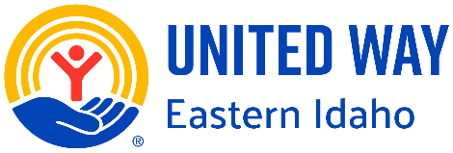**2025-26 United Way Letter of Intent**

*Due by April 4, 2025 at noon.*

# Organization

Physical Address:

Mailing Address (if different):

Phone Number:

Grant Contact:

Grant Contact Email:

Total Organization Budget:

Does your organization conduct an independent annual audit or independent financial review (please refer to Community Investment Guidelines)?

Does your organization have a reserve account (3-6 months operational expenses)? If so, how much?

Mission Statement:

# Program Name

Program Budget:

Requested Grant Funding Amount:

This proposal best matches United Way Eastern Idaho’s goals in the area of (Select one: ***Youth Opportunity, Healthy Community, or Financial Security***)

Please describe the program (150 words max.)

How does the program help to achieve United Way’s impact goals? (150 words max.)

How will the United Way funds be used? (150 words max.)

Please describe why you selected the above program and how it will benefit underserved individuals/families ALICE – Asset Limited, Income Constrained, Employed. (150 words max.)

Email completed LOI to [cmercau@unitedwayif.org](mailto:cmercau@unitedwayif.org)